Roll No: CS23110 | G3 | Areeba Khan
Task 1: Generate a script file which produces a sine wave with 2 Hz frequency.
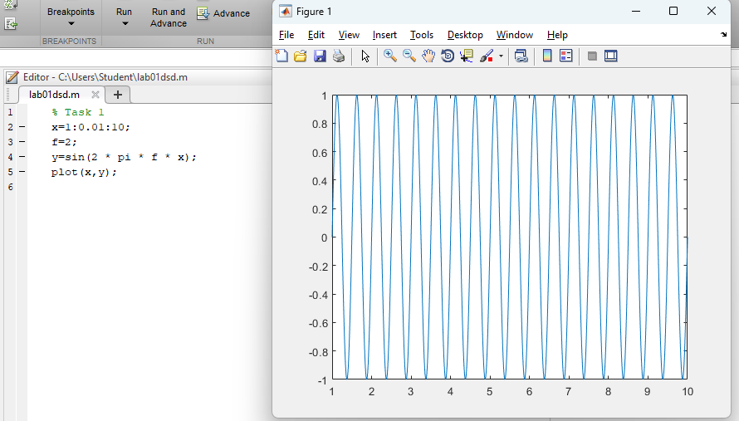
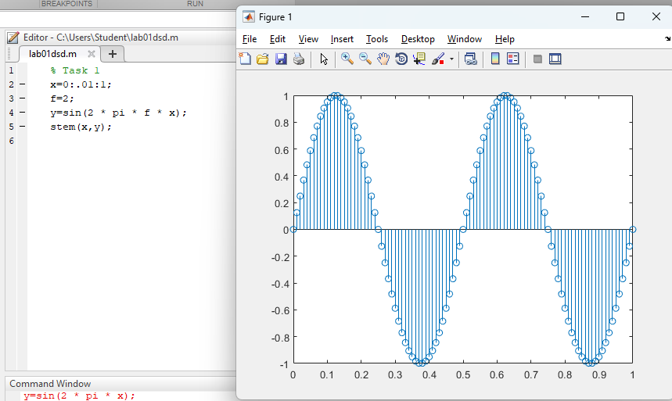

Task 2: Generate a script file which produces a sine wave by taking frequency as an input
at run time.

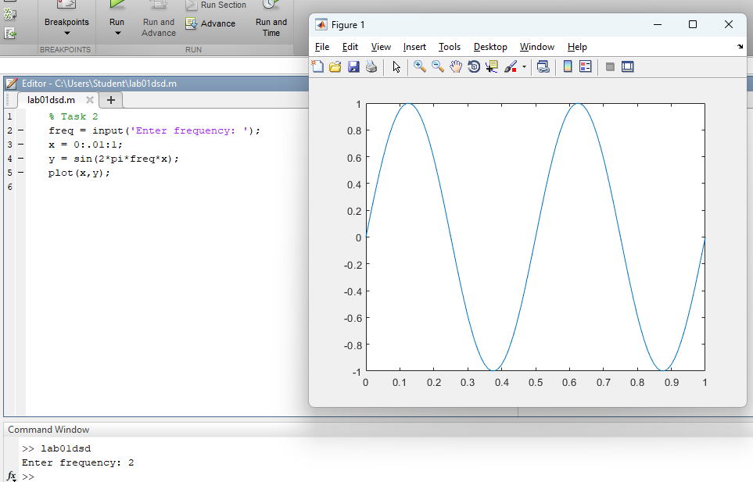
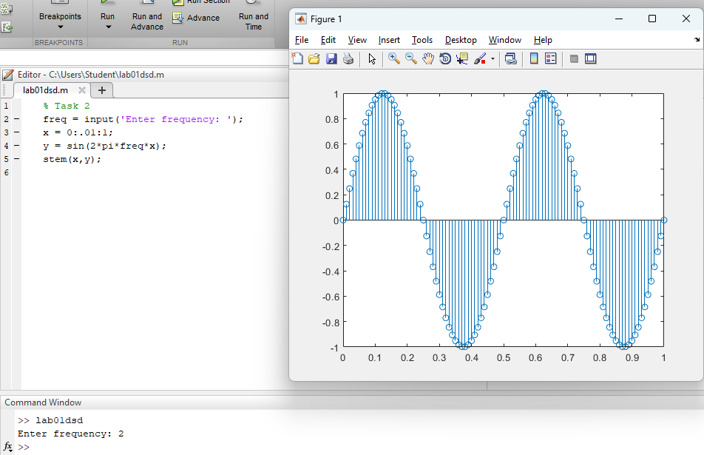

Task 3: Generate a script file which produces a sine wave with 2Hz, 5Hz, 10Hz and 20Hz
frequencies on a single figure by using subplot command. Label the subplots with the relevant
frequency to distinguish the signals clearly.
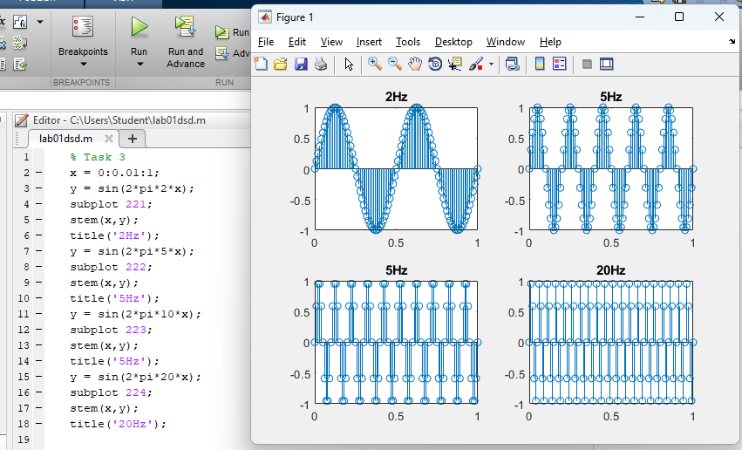
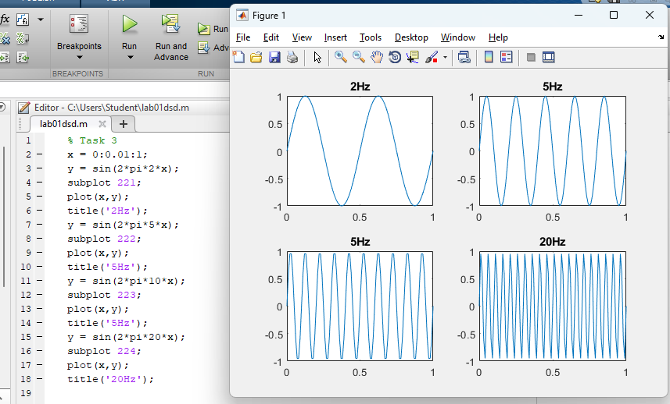

Task 4: Implement a function as defined below, which produces a sine wave of 1001
samples with spacing of 1 ms. [x]=sinewave(t)
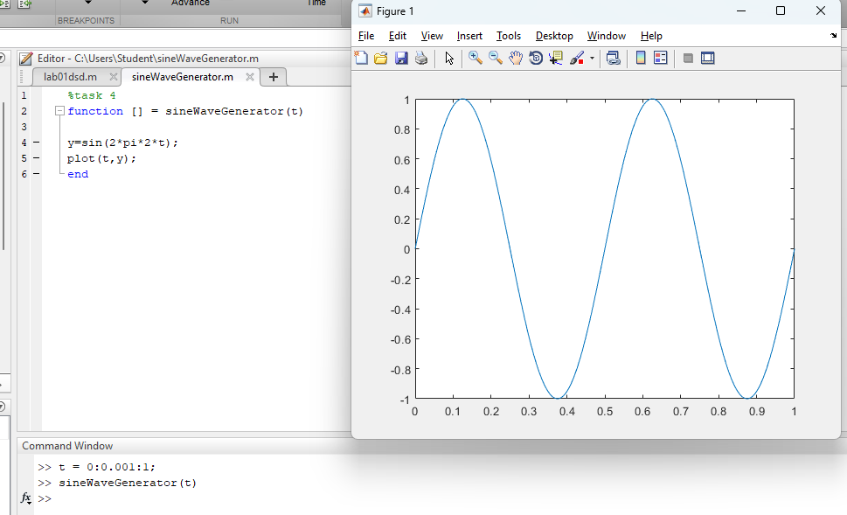
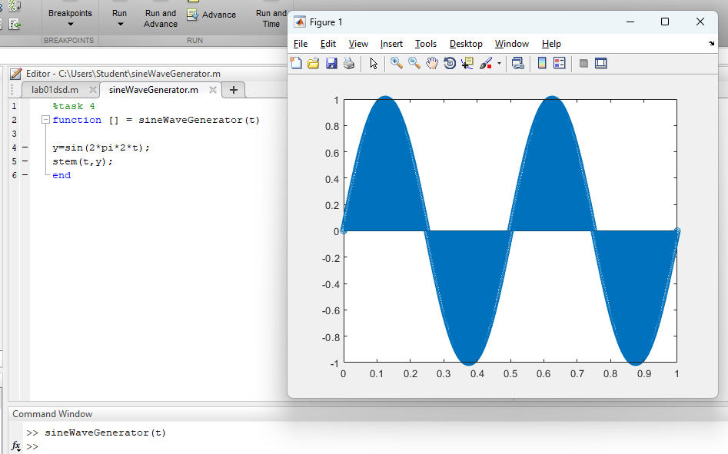

Task 5: Generate a function which produces a sine wave by accepting frequency and
amplitude as input arguments and return a plot of sine wave for the inputted parameters.
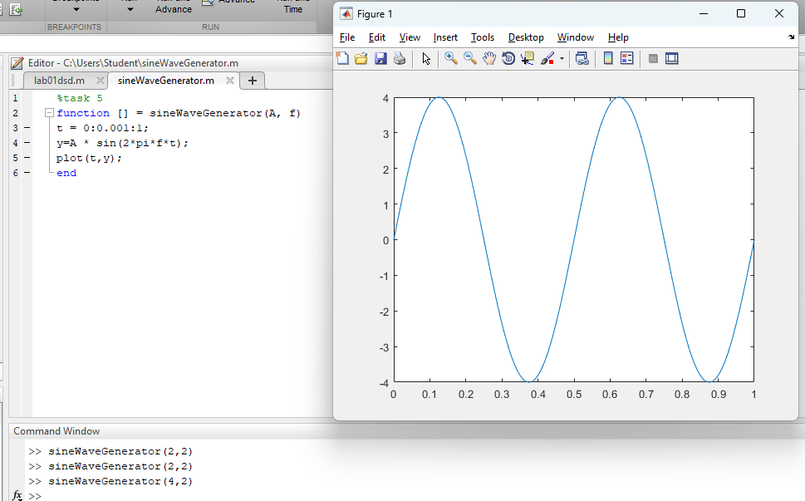
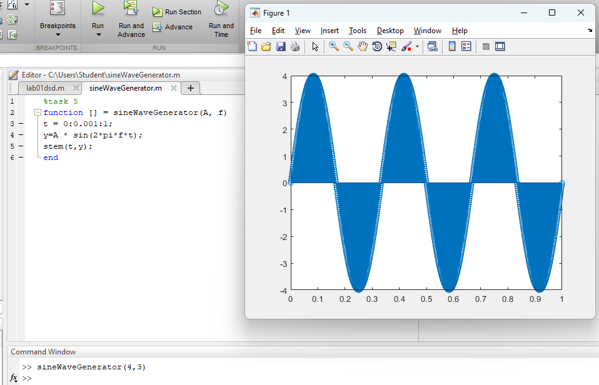

Task # 6: Repeat all the above tasks using the stem command instead of plot. (Same outputs so skipped)
Task 7: Write MATLAB function for plotting the 5 harmonics of a signal x(t)=cos(wt)
with a fundamental frequency of f = 0.5 Hz. Take t = 0:0.01:2
What are the frequencies and Time periods at the all 5 harmonics?
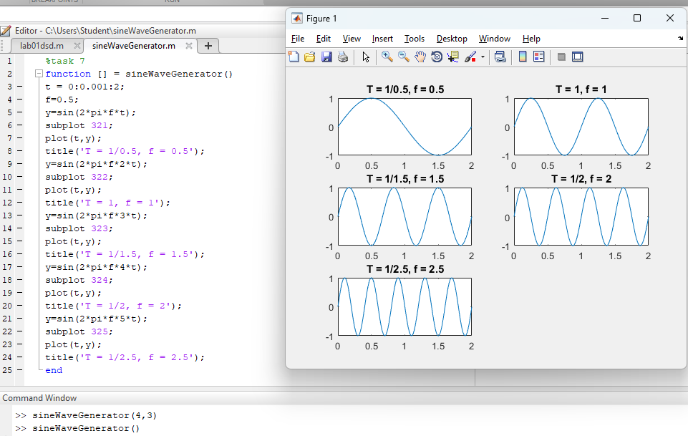
TASK 8: Try all help methods to get help of any function.
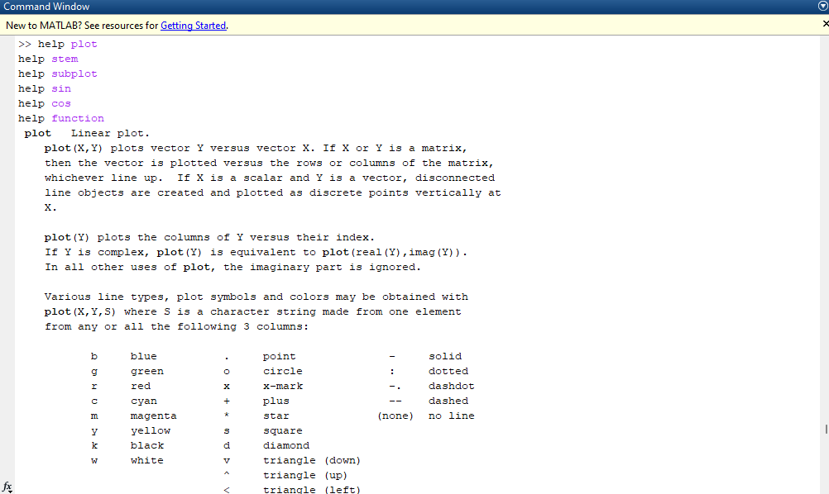
Task 9: (a) Assign 10 samples, from 0 to 9, of time to the vector t.
(b) Assign a vector of samples without assigning it to a variable.
(c) Assign 10 samples, from 0 to 9, of time to any vector without printing it to screen.
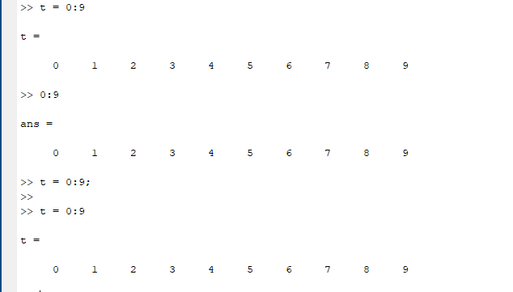
Task 10: Investigate the difference between multiplication*and element‐wise
multiplication.* of vectors/matrices.
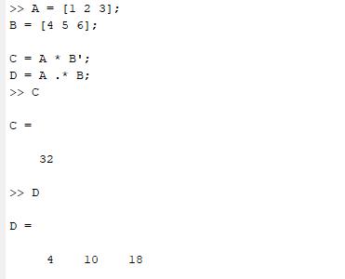

Task 11: Generate a complex‐valued matrix
a = ones (1,10)+ i* (1 : 10) and calculate the absolute square of all elements of this matrix.
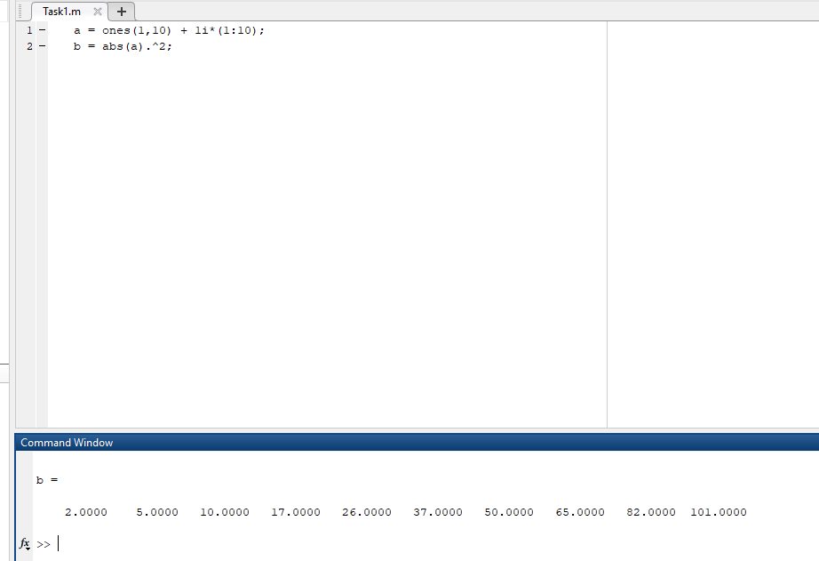
Task 12: Implement a function, [x]=sinewave(t), Which produces a sine wave of 1001 samples with spacing of ∆t= 1ms.
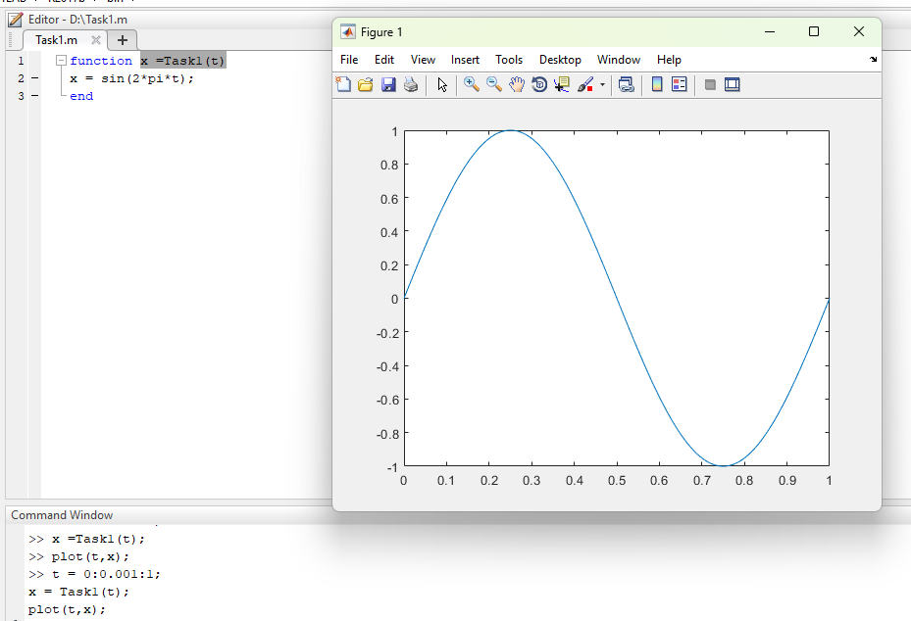
Task 13: Use MATLAB help to get familiar with the syntax of FOR, WHILE and IF‐
ELSE statement.
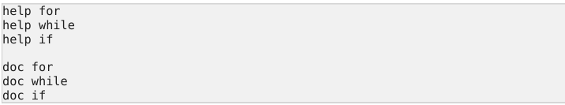
Task 14: Use FOR loop to generate a single vector y, which is a digitized unit sine wave
with ten samples per cycles, with 100 elements.
